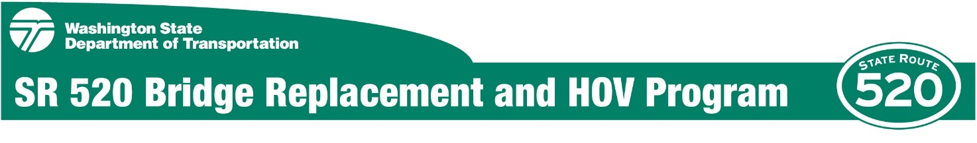

City of Seattle
Major Public Project Construction Noise Variance Application

Prepared for
Washington State Department of Transportation

Lead Author
Ginette Lalonde
WSP | Parsons Brinckerhoff

March 6, 2017

Table of Contents
Introduction 1
Project Descriptions and Proposed Construction Activities 3
Montlake Phase Overview and Project Site Description 3
Proposed Construction Activities 5
WSDOT Compliance with City of Seattle Criteria for a Major Public Project Construction Noise Variance 7
Definition of Major Public Project 7
SMC 25.08.168: The Definition of a Major Public Project 7
SMC 23.84A.030 “P”: The Definition of Public Facility 7
Criteria for Granting a Noise Variance 7
SMC 25.08.590.C: The Criteria for Granting a Noise Variance 7
Criteria for a Major Public Project Construction Noise Variance 8
SMC 25.08.655.A: The Criteria for an MPPCNV 8
Term of Proposed Variance 8
SMC 25.08.655.B: The Term of the Proposed Variance 8
Period the Variance is Effective 9
Construction Area and Exterior Nighttime Construction Noise-Level Limits 9
Noise Management and Mitigation Plan 13
Characteristics of Sound and Noise 13
Definition of Sound 13
Definition of Noise 13
Noise Level Descriptors 14
City of Seattle Noise Limits 15
Exceptions to the Seattle Noise Control Ordinance 15
Nighttime Noise Level Limits 16
Proposed Noisiest Nighttime Construction Periods 16
Montlake Phase – North Lid Wall and Center Lid Wall 17
Montlake Phase – North, South, and Center Lid Walls 20
Montlake Phase 3B – Demolition of Existing Montlake Blvd. E. Structure 22
Montlake Phase – Shaft Installation for WABS 24
Noise Mitigation 27
Minimum Mitigation Measures 27
Additional Noise-Control Measures 27
Public Outreach, Community Involvement, and Compliance 29
Online and Electronic Communications 29
Written Materials 29
Public Engagement Activities 30
Media Relations 30
Compliance Monitoring and Reporting 30

Acronyms and Abbreviations
ANSI | American National Standards Institute
dB | decibels
dBA | A-weighted decibels
HOV | high-occupancy vehicle
Hz | hertz
INM | Independent Noise Monitor
L_{eq} | equivalent sound level
L_{max} | maximum noise level
MPPCNV | Major Public Project Construction Noise Variance
NMMP | Noise Management and Mitigation Plan
SDCI | Seattle Department of Construction and Inspections
SMC | Seattle Municipal Code
SR | State Route
WABS | West Approach Bridge South
WAC | Washington Administrative Code
WSDOT | Washington State Department of Transportation

Introduction
The Washington State Department of Transportation (WSDOT) is submitting this application to the Seattle Department of Construction and Inspections (SDCI) to request a Major Public Project Construction Noise Variance (MPPCNV) for the Montlake Phase of the State Route (SR) 520 Bridge Replacement and High-Occupancy Vehicle (HOV) Program per the Noise Control Ordinance (Seattle Municipal Code, Chapter 25.08 [SMC 25.08]) and City of Seattle’s Director’s Rule 3-2009. This MPPCNV will cover activities occurring as part of the SR 520 Montlake Phase.
WSDOT requests an MPPCNV for the proposed Montlake Phase to allow necessary construction activities to occur during nighttime hours (between 10 p.m. and 7 a.m. on weekdays and between 10 p.m. and. 9 a.m. on weekends and legal holidays). WSDOT also requests that this MPPCNV allow impact work, including pile driving, to occur between 5 p.m. and 10 p.m. on weekdays and weekends in addition to regular daytime hours. As part of the MPPCNV for the Montlake Phase, this application proposes nighttime construction noise limits for noise-sensitive receivers near construction sites.
WSDOT requests an MPPCNV pursuant to SMC 25.08.590 (Granting of Variance) and SMC 25.08.655 (MPPCNV) to allow construction noise generated on site to exceed the sound level limit as specified in SMC 25.08.410 and as modified by 25.08.420 and 25.08.425. Completion of all construction activities during only daytime hours would be unreasonable in light of public or worker safety and would require multiple periods of closure of SR 520 and Montlake Boulevard during peak traffic periods and would result in extensive delays to the travelling public and increase traffic volumes on city streets. These delays would substantially extend the construction period.
This MPPCNV Application includes the following:
- A description of the proposed construction activities
- Existing baseline sound levels at noise-sensitive land uses within the project areas
- Proposed sound-level limits for construction activities covered by the MPPCNV
- Description of the noisiest proposed construction activities
- Calculated sound levels that may be expected at noise-sensitive land uses during the noisiest nighttime construction activities
- Proposed noise-mitigation measures
- Provisions for compliance tracking and actions taken to resolve public complaints

WSDOT is working with SDCI to meet the 90-day permit processing timeline for WSDOT projects on a state highway as outlined in Revised Code of Washington (RCW) 47.01.485. The legislative intent behind this law is to expand the opportunities for streamlining the delivery of essential transportation projects while maintaining natural resource protection. This requirement became effective when Governor Inslee signed 2ESSB 5994 into law on July 6, 2015. The following section has been added to the RCW as RCW 47.01.485:

(1) To the greatest extent practicable, a city, town, code city, or county must make a final determination on all permits required for a project on a state highway as defined in RCW 46.04.560 no later than 90 days after the department (WSDOT) submits a complete permit application for a project with an estimated cost of less than $500 million.

Project Descriptions and Proposed Construction Activities

Montlake Phase Overview and Project Site Description
The next SR 520 project phase, known as the Montlake Phase, includes construction of the West Approach Bridge South (WABS), Montlake lid and interchange, and a bicycle/pedestrian land bridge over the highway. Construction of this first phase of the I-5 to Lake Washington Project (also known as the “Rest of the West”) is scheduled to begin in 2018. The existing SR 520 west approach bridge is built on hollow columns, which are vulnerable to a catastrophic earthquake, and the roadway has narrow shoulders and lacks transit/HOV lanes. The WABS will connect eastbound traffic from Montlake to the new floating bridge. It will also feature a dedicated transit/HOV lane that will provide improved mobility for buses and carpools as they access the new floating bridge and continue to the Eastside.
The new Montlake interchange and lid will include direct-access connections for transit and HOV in addition to new bicycle and pedestrian connections to existing regional and local trails and routes. The Montlake lid will be a hub for local and regional transportation connectivity, and will include multifunctional open spaces, urban trails, undercrossings, a segment of the regional shared-use path adjacent to SR 520, and transit connections. The land bridge will be a bicycle/pedestrian path over SR 520 that provides a north-south local trail connection across the highway between the Washington Park Arboretum and points north. The Montlake Phase also features construction of stormwater treatment sites that will capture and naturally filter highway runoff to help protect the local environment.
Land uses and zoning classifications are mostly residential near the project area (Exhibit 1), with the exception of the corner of Montlake Boulevard and SR 520, which is zoned as neighborhood commercial.

Exhibit 1. Project Area
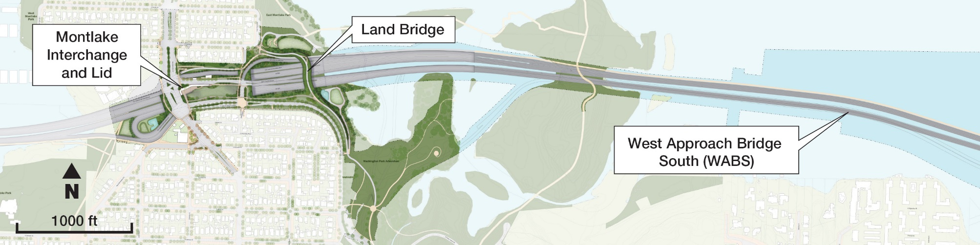

Proposed Construction Activities
The Montlake Phase will be a Design Build contract. WSDOT has developed likely construction activities and a schedule for this work. A request for proposals is planned to be issued by WSDOT in the spring of 2017. WSDOT will evaluate the proposals and choose a Design-Builder to complete the work. WSDOT expects to award the contract to the selected Design-Builder in late 2017 or early 2018. The Design-Builder will propose their own construction activities and schedule, and create a Noise Management and Mitigation Plan (NMMP). While the order and timing of activities may differ, the construction activities and equipment used are likely to be similar to those identified by WSDOT. The proposed Montlake Phase major construction activities and durations are as follows:
- Waterline Installation, estimated 5 to 7 months
- Demolition of Existing Bridge Montlake Boulevard, estimated 1 month
- Demolition of Existing 24th Avenue Bridge, estimated 1 month
- Demolition of Existing WABS, estimated 4 to 6 months
- Temporary Work Bridge Construction, estimated 5 to 7 months
- Drilled Shafts for WABS, estimated 12 to 16 months
- Bridge Substructure and Superstructure Construction for WABS, estimated 14 to 20 months
- Construction of Montlake Lid, estimated 48 to 65 months
- Traffic Shifts, estimated 48 to 65 months
- Utility Relocation, estimated 48 to 65 months
- Temporary Shoring Wall Construction, estimated 48 to 65 months
- West Approach Bridge North (WABN) Widening, estimated 48 to 65 months

WSDOT Compliance with City of Seattle Criteria for a Major Public Project Construction Noise Variance

Definition of Major Public Project

SMC 25.08.168: The Definition of a Major Public Project
SMC 25.08.168 defines “major public project” as follows:
“Major public project" means a project for a public facility as defined in SMC Title 23, the construction of which the Administrator determines is likely to be of at least six months duration, and is likely to have a substantial impact on the public safety, health and welfare and the provision of public services, including transportation services. In making this determination the Administrator shall consider factors such as the expected size, complexity or cost of the proposed construction or reconstruction; the expected duration of the proposed construction or reconstruction; the magnitude of the expected impacts on traffic and transportation; and/or the degree of impact on the provision of public services during the proposed construction or reconstruction.”

SMC 23.84A.030 “P”: The Definition of Public Facility
SMC 23.84A.030 “P” defines “public facility” as follows: “Public facility” means a public project or city facility.
The proposed Montlake Phase of the SR 520 Bridge Replacement and HOV Program is a “major public project” as defined in SMC 25.08.168 and are “public facilities” as defined in SMC 23.84.030. SR 520 plays a major role in sustaining the region’s economy and maintaining the ability to travel to and from Seattle. The SR 520 Bridge Replacement and HOV Program is making major enhancements to this vital urban highway. The program is improving traffic safety by replacing SR 520's aging and vulnerable bridges, while making other key highway improvements to enhance public mobility and transportation options throughout the corridor.
Work is scheduled to commence in summer 2018 with an estimated completion date of winter 2023. The length of the variance requested is 7 years to complete project closeout, including cleanup, dismantling of staging areas, and restoration where required by the permit conditions.

Criteria for Granting a Noise Variance

SMC 25.08.590.C: The Criteria for Granting a Noise Variance
SMC 25.08.590.C states:
    - The Administrator may grant a variance if the Administrator finds that:
      - The noise occurring or proposed to occur does not endanger public health or safety; and
      - The applicant demonstrates that the criteria required for the variance are met.
This MPPCNV application proposes nighttime construction noise limits for noise‐sensitive receivers in proximity to construction areas. The proposed noise limits include a 6‐dBA (A-weighted decibels) increase over existing hourly noise levels. This MPPCNV application presents the results of the modeled noisiest construction activities and demonstrates that the proposed noise level limits can be met.

Criteria for a Major Public Project Construction Noise Variance

SMC 25.08.655.A: The Criteria for an MPPCNV
The criteria for an MPPCNV are stated in SMC 25.08.655.A as follows:
- The Administrator may grant a major public project construction variance to provide relief from the exterior sound level limits established by this chapter during the construction periods of major public projects. A major public project construction variance shall provide relief from the exterior sound level limits during the construction or reconstruction of a major public project only to the extent the applicant demonstrates that compliance with the levels would:
  - Be unreasonable in light of public or worker safety or cause the applicant to violate other applicable regulations, including but not limited to regulations that reduce impacts on transportation infrastructure or natural resources; or
  - Render the project economically or functionally unreasonable due to factors such as the financial cost of compliance or the impact of complying for the duration of the construction or reconstruction of the major public project.
Limiting construction to daytime hours would be unreasonable in light of public or worker safety and would render the Montlake Phase economically and functionally unreasonable. The prime benefit of constructing on a continuous 24‐hour‐per‐day basis is that completion of the proposed project will bring major public transportation benefits and other benefits to all of the populations the completed facility would serve as quickly as possible. The sooner the proposed projects are completed, the sooner these benefits would be available to the public.
Allowing nighttime construction activities would not only allow for a more efficient and shorter construction period, it would also result in other public benefits, including substantial cost savings for the public and avoiding closures during peak travel periods. A shorter construction period has clear effects on costs: reduced administrative expenses, reduced length of construction time needed for equipment and personnel, and savings on the inflation that would otherwise compound the cost of construction in later years.
The approved variance would allow for a condensed construction schedule, which would lessen the duration of construction impacts (traffic, dust, vibration, and noise). Thus, there would be a reduction of overall inconvenience due to construction.

Term of Proposed Variance

SMC 25.08.655.B: The Term of the Proposed Variance
SMC 25.08.655.B states:
B. A major public project construction variance shall set forth the period or periods during which the variance is effective, which period or periods shall be the minimum reasonably necessary in light of the standard set forth in subsection A, and the exterior sound level limits that will be in effect during the period of the variance.

Period the Variance is Effective
WSDOT requests that construction noise generated on the site be allowed to exceed the sound level limit during nighttime hours (between 10 p.m. and 7 a.m. on weekdays and between 10 p.m. and. 9 a.m. on weekends and legal holidays). WSDOT also requests that this MPPCNV allow impact work, including equipment such as pile drivers, impact hammers, and jack hammers, to occur between 5 p.m. and 10 p.m. in addition to regular daytime hours.
The variance is requested for the length of time that is needed to complete construction of the Montlake Phase. Major construction is scheduled to begin in summer 2018, with an estimated completion date of winter 2023. There is a possibility some preliminary exploratory work necessitating nighttime closures may be required during winter/spring of 2018. The length of the variance requested is 7 years. This includes approximately 6 years to complete project closeout, including cleanup, dismantling of staging areas, and restoration where required by permit conditions. It also assumes that there will not be any significant or unexpected delays beyond the control of WSDOT of more than 1 year.
The Design-Builder would be able to perform nighttime construction work if the work is performed within the Montlake Phase construction area as described below and covered by this MPPCNV or any temporary noise variances granted by SDCI. The MPPCNV is subject to review by SDCI after the first year of construction, as provided in SMC 25.08.655.D. Additional coordination with SDCI would continue throughout construction.

Construction Area and Exterior Nighttime Construction Noise-Level Limits
This MPPCNV proposes nighttime construction noise limits for nighttime noise-sensitive receivers in proximity to the Montlake Phase construction area (Exhibit 2). Nighttime noise-sensitive receivers are generally properties where people are sleeping, such as a residence. Characteristics of noise and sound are discussed in the NMMP section.
This MPPCNV proposes a 6-dBA increase over existing noise levels. The nighttime construction noise-level limits for each noise-sensitive receptor location are determined by averaging the measured one-hour L_{eq} during the quietest part of the nighttime hours (the 5-hour period from 12 a.m. to 5 a.m. instead of 10 p.m. to 7 a.m.) and allowing a 6 dBA increase. These limits apply to the operation of construction equipment during nighttime hours from 10 p.m. to 7 a.m. on weekdays and 10 p.m. and 9 a.m. on weekends and legal holidays.
Continuous monitoring of A-weighted sound levels ranging in duration from 11 days to two weeks was conducted at seven sites (Exhibit 2). Measurements were taken during October and November 2016, and then again in January 2017 with calibrated Larson Davis Model 720 (Type 2) and 820 (Type 1) noise meters, which comply with American National Standards Institute S1.4 for instrument accuracy. All sound level monitoring equipment was calibrated before and after each measurement. In addition, the noise meters are calibrated annually by an accredited laboratory. The seven sites listed below were identified as representing nighttime noise-sensitive receivers near each construction area:
- Site 1 – 2449 E. Lake Washington Boulevard
- Site 2 – City of Seattle property near Montlake Boulevard Market
- Site 3 – Beaver Lodge Sanctuary
- Site 4 – 2740 Montlake Boulevard E.
- Site 5 – 2015 E. Roanoke St.
- Site 6 – 2800 block E. Park Drive East and WABN construction site (old MOHAI site)
- Site 7 – 2209 E. Lake Washington Boulevard
Exhibit 2. Construction Area and Noise measurement locations
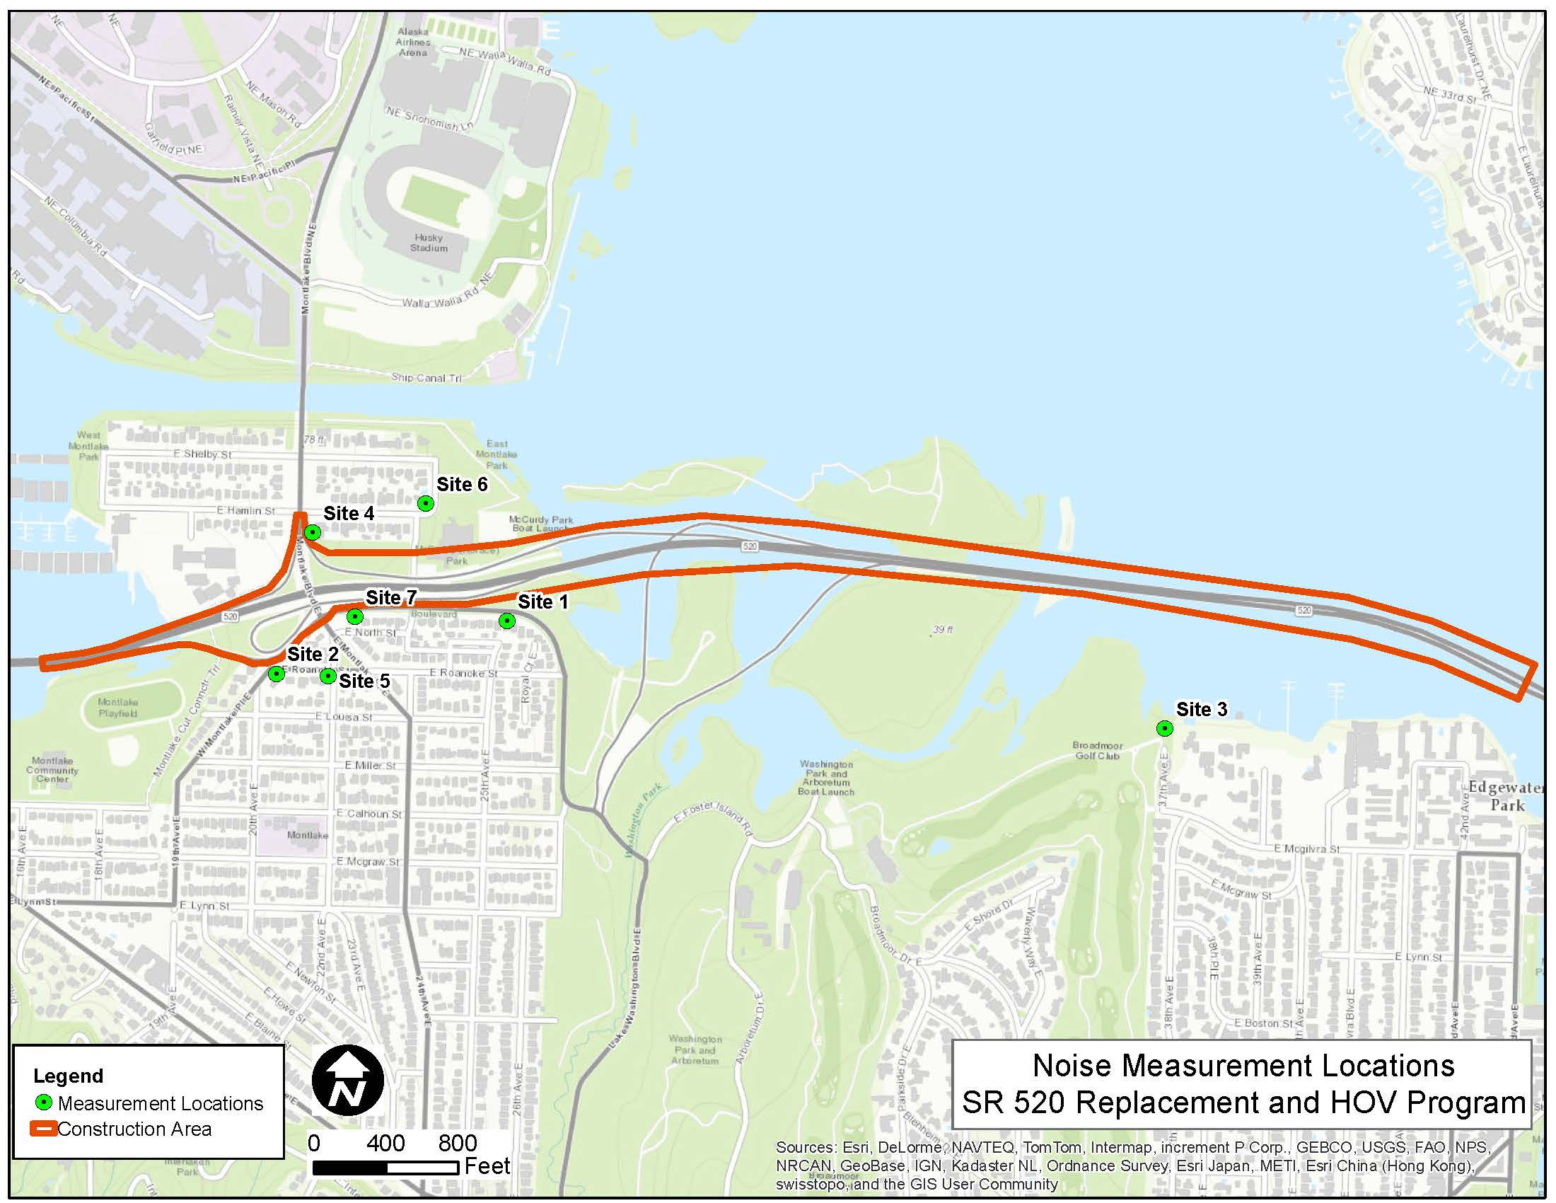

The baseline nighttime noise measurements taken between midnight and 5 a.m. are presented in Exhibit 3. Sound levels measured during the late night hours (midnight to 5 a.m.) provide the most conservative representation of the existing baseline condition. Noise measurement sites were selected based on their proximity to construction activities. A Noise Monitoring Plan will be prepared by the Design-Builder to coincide with the NMMP.

Exhibit 3. Baseline Noise Levels and Proposed Nighttime Noise Level Limits
Site | 12 to 5 AM Log Hourly Average L_{eq}  (dBA) | Proposed Nighttime Noise Level Hourly Limit L_{eq} (dBA) | 12 to 5 AM L_{max} range (dBA) | Proposed Nighttime Noise Level Hourly Limit L₁ (dBA)
1 | 61 | 67 | 71.2 to 82.5 | 80
2 | 72 | 78 | 72.4 to 89.3 | 80
3 | 56 | 62 | 55.3 to 77.5 | 80
4 | 60 | 66 | 74.5 to 94.3 | 80
5 | 59 | 65 | 45.3 to 90.1 | 80
6 | 57 | 63 | 52.7 to 92.0 | 80
7 | 60 | 66 | 70.2 to 91.8 | 80
The measured existing nighttime sound levels exceed the City of Seattle nighttime noise limits of 45 dBA (L_{eq}) at all monitoring locations. The existing sound levels, which are produced primarily by traffic on public roads, are not subject to the limits of SMC 25.08.410-425. The comparison is presented as a baseline for evaluating potential noise impacts from proposed construction activities.
The MPPCNV can also establish a highest maximum noise level limit above the nighttime equivalent sound level (L_{eq}) to account for potential short‐term noises. Hourly Percentile Sound Levels, L_{n}, are the sound levels exceeded for “n” percent of an hour. The measured L₁ is the sound level exceeded for 1 percent of the measurement duration (i.e., 36 seconds per hour). The L₁ will have an upper limit of 80 dBA, which is the daytime construction noise‐level limit at residentially zoned receivers. The proposed L₁ limit would be in the range of existing L_{max} sound levels measured during the late-night hours of midnight to 5 a.m. in the Montlake Lid construction area (Sites 1, 2, 4, 5, and 6). The proposed L₁ would exceed the range of existing L_{max} sound levels by 3 dBA in the WABS construction area (Site 3). In addition to the L_{eq}, the MPPCNV application proposes to track compliance with the terms of the MPPCNV by monitoring the measured hourly L₁ sound level. For the purpose of monitoring construction sound levels, the hourly L₁ has been found to be more reliable than the hourly L_{max} in tracking compliance with MPPCNV limits. As with the L_{max}, the hourly L₁ provides a representative measure of the worst-case sound levels produced by a construction activity; unlike the L_{max}, the L₁ is not susceptible to distortion by one-time, atypical events such as a tool or load being dropped, and it is more representative of sound levels produced during higher-intensity construction activities each hour.

Noise Management and Mitigation Plan
This NMMP section provides a framework for the NMMP to be prepared by the Design-Builder. This section summarizes a noise analysis for the likely construction activities of the Montlake Phase of the SR 520 Bridge Replacement and HOV Program. This section was prepared according to the requirements of Section 25.08.655 of the Seattle Municipal Code and Director’s Rule DR3-2009, both pertaining to Major Public Project Construction Noise Variances from the City of Seattle Noise Code.
WSDOT has developed likely construction activities and a schedule for the Montlake Phase. The analysis in this NMMP section demonstrates that means and methods are available to meet the noise limits requested in this MPPCNV. The Design-Builder will propose their own construction activities and schedule, and create a detailed NMMP to meet the commitments WSDOT has made in this MPPCNV application and the MPPCNV issued by SDCI. Construction activities and equipment used may not be specifically identical but are likely to be similar to those identified by WSDOT below.

Characteristics of Sound and Noise

Definition of Sound
Sound is created when objects vibrate, resulting in a minute variation in surrounding atmospheric pressure, called sound pressure. The human response to sound depends on the magnitude of a sound as a function of its frequency and time pattern. Magnitude is a measure of the physical sound energy in the air. The range of magnitude the ear can hear, from the faintest to the loudest sound, is so large that sound pressure is expressed on a logarithmic scale in units called decibels (dB). Loudness refers to how people subjectively judge a sound and varies between people.
Sound is measured using the logarithmic decibel scale, so doubling the number of noise sources, such as the number of cars on a roadway, increases noise levels by 3 dBA. Therefore, when you combine two noise sources emitting 60 dBA, the combined noise level is 63 dBA, not 120 dBA. The human ear can barely perceive a 3 dBA increase, while a 5 dBA increase is about one and one-half times as loud. A 10 dBA increase appears to be a doubling in noise level to most listeners. A tenfold increase in the number of noise sources will add 10 dBA.
In addition to magnitude, humans also respond to a sound's frequency or pitch. The human ear is very effective at perceiving frequencies between 1,000 and 5,000 hertz (Hz), with less efficiency outside this range. Environmental noise is composed of many frequencies. A-weighting (dBA) of sound levels is applied electronically by a sound level meter and combines the many frequencies into one sound level that simulates how an average person hears sounds of low to moderate magnitude.

Definition of Noise
Noise is unwanted or unpleasant sound. Noise is a subjective term because, as described above, sound levels are perceived differently by different people. Magnitudes of typical noise levels are presented in Exhibit 4.
Exhibit 4. Typical Noise Levels
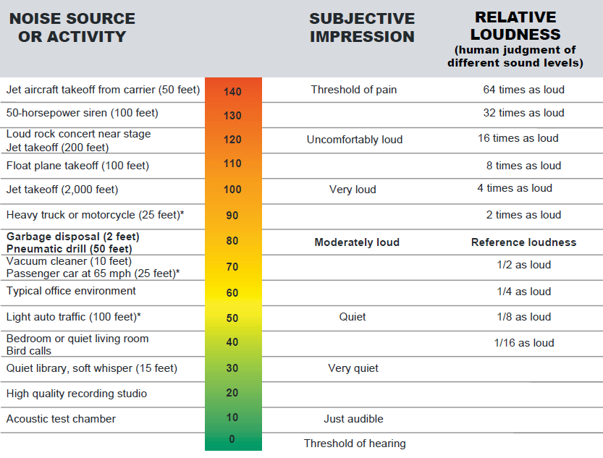

Noise Level Descriptors
The L_{eq} is a measure of the average noise level during a specified period of time. A one-hour period, or hourly L_{eq}, is used to measure construction noise. L_{eq} is a measure of total noise during a time period that places more emphasis on occasional high noise levels that accompany general background noise levels. For example, if you have two different sounds, and one contains twice as much energy, but lasts only half as long as the other, the two would have the same L_{eq} noise levels.
Either the total noise energy or the highest instantaneous noise level can describe short-term noise levels. L_{max} is the maximum sound level that occurs during a single event and is related to impacts on speech interference and sleep disruption.
With L_{n}, “n” is the percent of time that a sound level is exceeded and is used to describe the range and pattern of sound levels experienced during the measurement period. For example, the L₁ level is the noise level that is exceeded 1 percent of the time. Sound varies in the environment and people will generally find a higher, but constant, sound level more tolerable than a quiet background level interrupted by higher sound level events. For example, steady traffic noise from a highway is normally less bothersome than occasional aircraft flyovers in an otherwise quiet area if both environments have the same L_{eq}.

City of Seattle Noise Limits
The City limits noise levels at property lines of neighboring properties (Seattle Noise Control Ordinance, SMC 25.08.410). The sound level limit depends on the land uses of both the noise source and the receiving property (Exhibit 5). The Montlake Phase and the properties surrounding the construction sites are zoned residential, with the exception of the corner of Montlake Boulevard and SR 520, which is zoned as neighborhood commercial. The sound level limits apply to construction activities only if they occur between 10 p.m. and 7 a.m. on weekdays or 10 p.m. and 9 a.m. on weekends and legal holidays. Legal holidays are defined in SMC 25.08.155 as New Year’s Day, Memorial Day, Independence Day, Labor Day, Thanksgiving Day and the day after, and Christmas Day. Construction activities during nighttime hours that would exceed these levels require a noise variance from the City.
Exhibit 5. Seattle Noise Control Ordinance – Exterior Sound Level Limits
 | District of Receiving Property
District of Sound Source | Residential  Daytime  L_{eq} (dBA) | Residential Nighttime  L_{eq} (dBA) | Commercial  L_{eq} (dBA) | Industrial  L_{eq} (dBA)
Residential | 55 | 45 | 57 | 60
Commercial | 57 | 47 | 60 | 65
Industrial | 60 | 50 | 65 | 70

Notes:
Nighttime hours are 10 p.m. to 7 a.m. during weekdays and 10 p.m. to 9 a.m. during weekends and legal holidays
dBA = A-weighted decibels
L_{eq} = equivalent sound level
During a measurement interval, L_{max} may exceed the exterior sound level limits shown by no more than 15 dBA.

Exceptions to the Seattle Noise Control Ordinance
Noise levels shown in Exhibit 5 may be exceeded by construction equipment between 7 a.m. and 10 p.m. on weekdays and between 9 a.m. and 10 p.m. on weekends and legal holidays. Threshold levels for equipment are listed below:
- 25 A-weighted decibels (dBA) for equipment on construction sites, including but not limited to, crawlers, tractors, dozers, rotary drills and augers, loaders, power shovels, cranes, derricks, graders, off-highway trucks, ditchers, trenchers, compactors, compressors, derrick barges, tug boats, and pneumatic-powered equipment
Daytime construction activity is allowed to exceed the noise-level limits in the Seattle Noise Control Ordinance (SMC 25.08.425) (Exhibit 5) by 25 dBA. These levels should be measured from the real property of another person or at a distance of 50 feet from the equipment, whichever is greater. Construction activities for the Montlake Phase would mostly occur in a residential district. The daytime construction activity associated with the Montlake Phase would be limited to 80 dBA (55 dBA + 25 dBA) for residential districts.
In addition, the Seattle Noise Control Ordinance (SMC 25.08.425) regulates sound created by impact types of construction equipment (e.g., pavement breakers, pile drivers, jackhammers, and sandblasting tools) or those that otherwise create impulse or impact noise (as measured at the property line or 50 feet from the equipment, whichever is greater). The equipment may exceed the sound level limits (equivalent sound level [L_{eq}] described in Exhibit 5) in any 1-hour period between 8 a.m. and 5 p.m. on weekdays and 9 a.m. and 5 p.m. on weekends and legal holidays. The sound level is in no event to exceed the following:
- L_{eq} = 90 dBA continuously
- L_{eq} = 93 dBA for 30 minutes
- L_{eq} = 96 dBA for 15 minutes
- L_{eq} = 99 dBA for 7.5 minutes
Sound levels in excess of L_{eq} = 99 dBA are prohibited unless authorized by variance. The standard of measurement is a 1-hour L_{eq} measured for time periods not less than 1 minute in order to project an hourly L_{eq}.

Nighttime Noise Level Limits
Noise level limits (Exhibit 3) were established in the section above, WSDOT Compliance with City of Seattle Criteria for a Major Public Project Construction Noise Variance.

Proposed Noisiest Nighttime Construction Periods
Projected nighttime major construction noise levels were modeled for selected noise‐sensitive receivers using Sound PLAN Version 7.0, a three‐dimensional graphics‐oriented program for outdoor noise propagation. For nighttime construction noise estimates, the noisiest nighttime construction activity that would occur at the surface of each construction site and the noisiest equipment during this activity was assumed. Impact work is prohibited during nighttime hours; therefore, that type of equipment has not been modeled. The noisiest equipment was modeled to provide a conservative estimate of noise levels. A variety of construction activities are anticipated to occur within the footprint of the Montlake Phase, potentially using the equipment outlined in Exhibit 6. Construction noise includes truck operations within the construction site and not on haul routes. Haul routes are not regulated under the Noise Control Ordinance and, therefore, are not included in this application.

Exhibit 6. Typical Construction Equipment Noise levels
Equipment Type | Typical Noise Level (dBA) at 50 Feet
Hydraulic Crane | 88
Crawler Crane | 83
Concrete Pump | 82
Compressors | 81
Trucks (including Concrete, Dump & Debris Trucks) | 88
Vibratory Pile Installer | 96
Welder | 82
Diesel Generator | 81
Excavators with crusher | 96
Loader | 85
Excavators w/ thumb | 96
Drill Rig | 83
Source: August 2006 FHWA Construction Noise Handbook, Section 9 found at: https://www.fhwa.dot.gov/Environment/noise/construction_noise/handbook/

Major construction activities were modeled for four construction periods to estimate the anticipated highest nighttime construction noise levels. The noise levels for the four different construction periods are described in the following subsections.
Construction may not occur on all nights, and construction during other phases of work would generate less noise. The modeled levels represent the loudest nights that are anticipated over the construction period.

Montlake Phase – North Lid Wall and Center Lid Wall
Modeled noise levels for one of the noisiest nighttime construction periods for portions of the construction of the Montlake structure are shown in Exhibit 7. Exhibit 8 shows the areas of construction of the North Lid Wall (identified as wall sections 2N-W and 2S-B), and the Center Lid Wall (identified as wall sections 2C-A and 2S-A). These two activities are currently estimated by WSDOT to occur at the same time for a period of three to four months. Equipment used for each activity was estimated to include a hydraulic crane, crawler crane, concrete pump, two compressors, and five concrete trucks. Unmitigated noise levels would exceed the L_{eq} noise level limit at Site 4 and Site 7, and for a few residences near Site 1, Site 4, and Site 7. The Loudest Constructed Noise Level is identified in Exhibit 8. No specific piece of equipment is responsible for the nighttime L_{eq} exceedances.
Exhibit 7. North Lid Wall and Center Lid Noise Levels
Site | Unmitigated Average Hourly L_{eq}  (dBA) | Mitigated Average Hourly L_{eq}  (dBA) | Proposed Nighttime Noise Level Hourly Limit L_{eq} (dBA) | Unmitigated Average Hourly L₁ (dBA) | Mitigated Average Hourly L₁ (dBA) | Proposed Nighttime Noise Level Hourly Limit L₁ (dBA)
1 | 61 | 61 | 67 | 63 | 63 | 80
2 | 62 | 61 | 78 | 64 | 64 | 80
3 | - | - | 62 | - | - | 80
4 | 67 | 63 | 66 | 69 | 65 | 80
5 | 58 | 57 | 65 | 60 | 59 | 80
6 | 56 | 56 | 63 | 58 | 58 | 80
7 | 68 | 64 | 66 | 70 | 66 | 80
Max Unmitigated Locations | 71 near Site 1 and between Sites 4 and 6 | 62 near Site 1  64 between Sites 4 and 6 | 67 (same as Site 1 and Site 4) | 71 | 64 near Site 1  66 near Site 4 | 80

Noise contours without mitigation are shown in Exhibit 8. Modeled equipment locations were selected to represent noise levels when equipment is located nearest noise-sensitive receivers. Noise levels were also modeled using temporary noise barriers (Exhibit 7) to confirm that the Design-Builder can reduce noise levels below the nighttime noise level limit for all residences. The Design-Builder could choose other mitigation measures as described in the compliance section below to reduce the noise level below the nighttime limits. The Design-Builder will detail construction methods, schedule, and mitigation measures in their NMMP.

Exhibit 8. North Lid Wall and Center Lid Construction Noise Level Contours
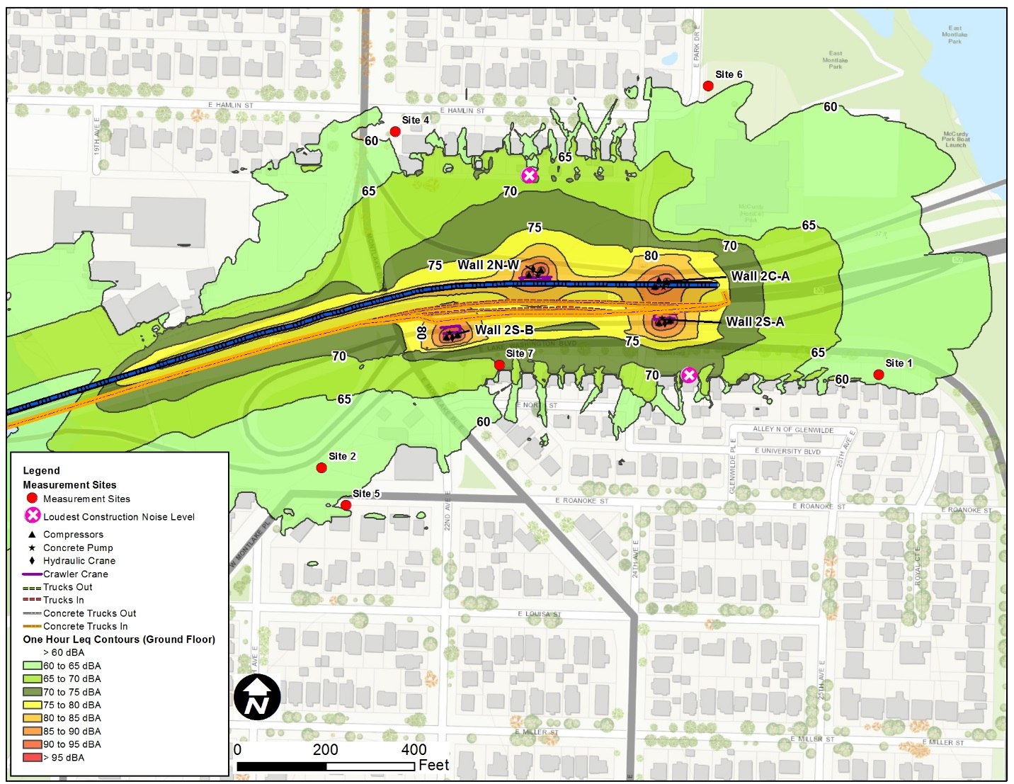

Montlake Phase – North, South, and Center Lid Walls
Modeled noise levels for another of the noisiest nighttime construction periods for portions of the construction of the Montlake structure are shown in Exhibit 9. Exhibit 10 shows the construction activities for the North Lid Wall (identified as 5N-A), the South Lid Wall (identified as 5S-A), the Center Lid Wall (identified as Wall 5C-A), and construction of the Montlake Lid adjacent to Montlake Boulevard E. Although each activity would occur over a period of three to four months, they would have different start dates, and are currently estimated by WSDOT to all overlap for approximately one month. Equipment used for each activity was estimated to include a hydraulic crane, crawler crane, concrete pump, two compressors, and five concrete trucks. Unmitigated noise levels would exceed the L_{eq} noise level limit at Site 4 and Site 7, and for a few residences near Site 4 and Site 7. The Loudest Constructed Noise Level is identified in Exhibit 10. No specific piece of equipment is responsible for the nighttime L_{eq} exceedances.
Exhibit 9. North, South and center Lid Walls Modeled Noise Levels
Site | Unmitigated Average Hourly L_{eq}  (dBA) | Mitigated Average Hourly L_{eq}  (dBA) | Proposed Nighttime Noise Level Hourly Limit L_{eq} (dBA) | Unmitigated Average Hourly L₁ (dBA) | Mitigated Average Hourly L₁ (dBA) | Proposed Nighttime Noise Level Hourly Limit L₁ (dBA)
1 | 59 | 59 | 67 | 62 | 61 | 80
2 | 60 | 59 | 78 | 62 | 61 | 80
3 | - | - | 62 | - | - | 80
4 | 67 | 63 | 66 | 69 | 65 | 80
5 | 57 | 55 | 65 | 59 | 57 | 80
6 | 50 | 49 | 63 | 52 | 51 | 80
7 | 70 | 64 | 66 | 72 | 67 | 80
Max Unmitigated Location | 72 between Sites 4 and 6 | 66 between Sites 4 and 6 | 69 (same as Site 4) | 74 | 69 | 80

Noise contours without mitigation are shown in Exhibit 10. Modeled equipment locations were selected to represent noise levels when equipment is located nearest noise-sensitive receivers. Noise levels were also modeled using temporary noise barriers (Exhibit 9) to confirm that the Design- Builder can reduce noise levels below the nighttime noise level limit for all residences. The Design- Builder could choose other mitigation measures as described in the compliance section below to reduce the noise level below the nighttime limits. The Design-Builder will detail construction methods, schedule, and mitigation measures in their NMMP.

Exhibit 10. North, South, and center Lid Walls Construction Noise Level Contours
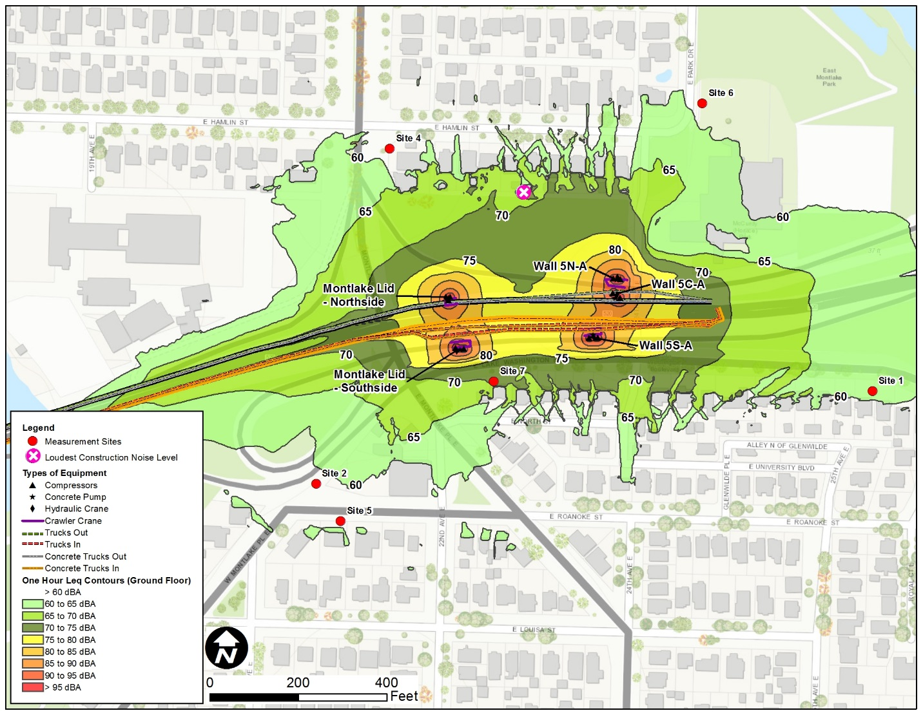

Montlake Phase 3B – Demolition of Existing Montlake Blvd. E. Structure
Demolition of the existing Montlake Boulevard E. structure is estimated to take one month. Equipment modeled during nighttime hours was estimated to include two excavators with crushers, three compressors, five dump trucks, one loader, fifteen debris trucks, and one excavator with thumb. Excavators with impact hammers would be used during daytime hours, but impact work is not allowed during nighttime hours; therefore, impact hammers have not been modeled during the nighttime. Modeled noise levels are shown in Exhibit 11. Unmitigated noise levels would exceed the L_{eq} noise level limit at Site 4 and Site 7, the Loudest Constructed Noise Level is near Site 7 shown in Exhibit 12. No specific piece of equipment is responsible for the nighttime L_{eq} exceedances.
Exhibit 11. Deomolition of Existing Monlake Blvd E. Structure Noise Levels without Impact Hammer
Site | Unmitigated Average Hourly L_{eq}  (dBA) | Mitigated Average Hourly L_{eq}  (dBA) | Proposed Nighttime Noise Level Hourly Limit L_{eq} (dBA) | Unmitigated Average Hourly L₁ (dBA) | Mitigated Average Hourly L₁ (dBA) | Proposed Nighttime Noise Level Hourly Limit L₁ (dBA)
1 | 46 | 41 | 67 | 48 | 48 | 80
2 | 64 | 65 | 78 | 66 | 68 | 80
3 | - | - | 62 | - | - | 80
4 | 67 | 64 | 66 | 69 | 66 | 80
5 | 61 | 62 | 65 | 64 | 65 | 80
6 | 45 | 45 | 63 | 47 | 47 | 80
7 | 70 | 62 | 66 | 75 | 65 | 80

Noise contours without mitigation are shown in Exhibit 12. Modeled equipment locations were selected to represent noise levels when equipment is located nearest noise-sensitive receivers. Noise levels were also modeled using temporary noise barriers (Exhibit 11) to confirm that the Design-Builder can reduce noise levels below the nighttime noise level limit for all residences. The Design-Builder could choose other mitigation measures as described in the compliance section below to reduce the noise level below the nighttime limits. The Design-Builder will detail construction methods, schedule, and mitigation measures in their NMMP.

Exhibit 12. Deomolition of Existing Monlake Blvd E. Structure without Impact Hammer Construction Noise Level Contours
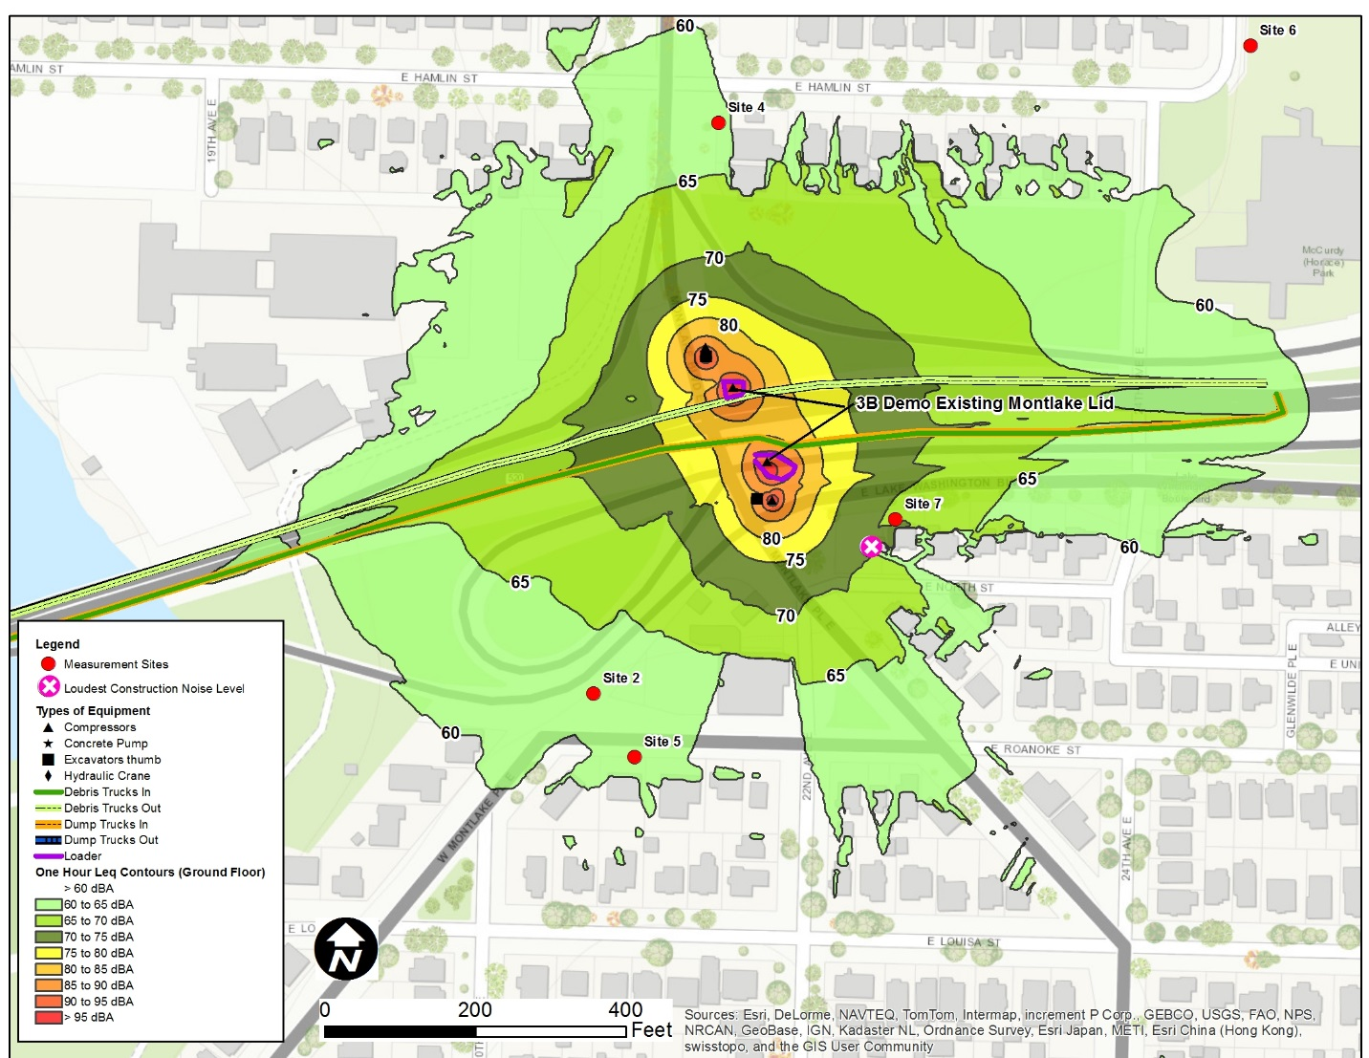

Montlake Phase – Shaft Installation for WABS
Non-impact shaft casing installation for the WABS structure construction is anticipated to take six months and would be the loudest activity along the WABS corridor. Nighttime noise levels were predicted near Site 3. Equipment modeled during nighttime hours include a crawler crane, two welders, a diesel generator, a drill rig, a vibratory pile installer, eight concrete trucks, and one concrete pump. Unmitigated noise levels would be below the L_{eq} noise level limit (Exhibit 13). No specific piece of equipment is responsible for the nighttime L_{eq} exceedances.
Exhibit 13. Shaft Installation for WABS
Site | Average Hourly L_{eq}  (dBA) | Proposed Nighttime Noise Level Hourly Limit L_{eq} (dBA) | Average Hourly L₁ (dBA) | Proposed Nighttime Noise Level Hourly Limit L₁ (dBA)
3 | 59 | 62 | 62 | 80

No mitigation would be needed to meet the proposed nighttime noise level limits. Noise contours are shown in Exhibit 14. Modeled equipment locations were selected to represent noise levels when equipment is located nearest noise-sensitive receivers.

Exhibit 14. Shaft Installation for WABS Noise Level Contours
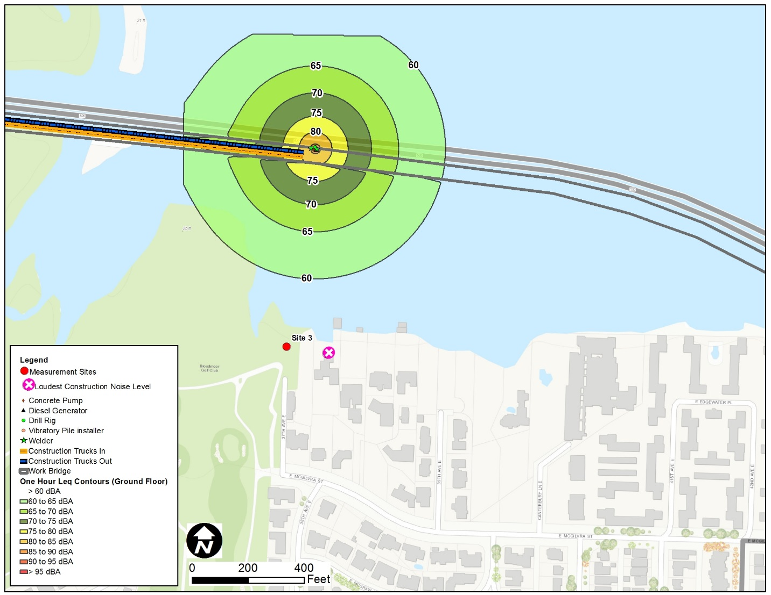

Noise Mitigation

Minimum Mitigation Measures
Except in the case of emergency, as defined by the Seattle Noise Control Ordinance (SMC 25.08.110), whenever the contractors work between 10 p.m. and 7 a.m. Monday through Friday, or between 10 p.m. and 9 a.m. Saturday through Sunday and legal holidays, and exceed the local ordinance noise levels, the Design-Builder will perform the following measures to minimize construction noise:
- The Design-Builder will meet the noise levels limits established in the MPPCNV.
- The Design-Builder will use broadband or strobe backup warning devices, or use backup observers in lieu of backup warning devices for all equipment, in compliance with Washington Administration Code, Sections 296-155-610 and 296-155-615. For dump trucks, if the surrounding noise level is so loud that broadband or strobe backup warning devices are not effective, then an observer must be used (WAC 296-155-610). This condition will apply to activity conducted between 10 p.m. and 7 a.m., Monday through Friday, and between 10 p.m. and 9 a.m. on Saturday, Sunday, and legal holidays. No pure-tone backup warning devices will be used after 10 p.m. and before 7 a.m. weekdays or 9 a.m. weekends and legal holidays.
- The Design-Builder will not allow impact work, such as jack hammering and impact pile driving, during nighttime hours from 10 p.m. to 8 a.m. on weekdays and 10 p.m. to 9 a.m. on weekends and legal holidays.

Additional Noise-Control Measures
The Design-Builder will submit to WSDOT an NMMP and will detail the additional mitigation measures needed to meet the noise level limits established in the MPPCNV. Once WSDOT has reviewed and accepted the NMMP, the Design-Builder will submit it to SDCI. Additional mitigation measures that the Design-Builder could also use as necessary are listed below:
- Equip nighttime surface equipment with high-grade engine-exhaust silencers and engine-casing sound insulation
- Enclose electrical generators, pumps, and air compressors
- Use electric welders powered from utility main lines instead of gas, diesel, or internal combustion generators/welders
- Use a noise mitigation shield on stationary equipment, such as light plants and generators. Other machinery for off-road use, such as cranes, could use double mufflers where practicable
- Use noise blankets, skirts, or other available means for mobile equipment to mitigate noise that does not unreasonably interfere with the operation of the engine
- Use mobile noise barriers in the immediate vicinity of loud activities
- Use temporary noise barriers
- Provide earplugs and white noise machines
- Install temporary sound dampening drapes
- Pave construction access roads and haul routes near residential areas

Public Outreach, Community Involvement, and Compliance
WSDOT believes public involvement is essential to a project’s development and has implemented a comprehensive and ongoing public involvement program for the SR 520 Bridge Replacement and HOV Program. During construction of the Montlake Phase, WSDOT’s communications team, in coordination with the City of Seattle and the selected Design-Builder, will provide up-to-date information on construction activities and construction noise to neighbors and stakeholders.
WSDOT’s approach to construction communications and descriptions of the various communications tools and activities are included below. WSDOT will keep the public informed of construction activities, promote two-way communication with the community, and work to minimize construction impacts.
As part of preparing for construction in the Montlake area in 2018, WSDOT will hire an SR 520 Ombudsman/Community Liaison to support WSDOT’s commitment to public involvement. The SR 520 Ombudsman position will serve as a strategic liaison between WSDOT, the Seattle communities affected by construction of the new SR 520 corridor, and the elected officials who represent these communities. The position will oversee and develop high-level engagement and issue resolution.

Online and Electronic Communications
- WSDOT maintains an electronic mailing list, and regular e-mail updates are sent to provide status updates and information on current activities.
- The project website is updated regularly and provides the latest design and construction information.
- WSDOT collaborates with other agencies and organizations to provide information in their respective e-mail updates or websites.
- SR 520 social media accounts are maintained on Twitter, Flickr, and YouTube.
- A 24-hour live telephone construction hotline will be maintained for the project. Real time responses to immediate concerns and updates of the project status and current construction activities and impacts will be provided.
- During business hours, community members may contact the SR 520 Program Information Line for non-urgent, general project information.
- Detailed responses will be provided to emails received via the project e-mail address.
- Highway advisory radio, variable message signs, active traffic management signs, and project identification signs will be used as needed.
- During business hours, a Montlake Phase storefront will serve as an in-person location for neighbors to receive answers to construction-related questions.

Written Materials
WSDOT uses a combination of written materials to provide advance notification and keep people informed of construction activities. All written materials have program contact information, including the hotline number, email address, and website. Types of materials are listed below:
- Fact sheets provide background information for the type of work occurring and project benefits.
- Fliers are created and often delivered door-to-door when there are localized construction impacts.
- Mailers are sent to neighbors in compliance with permitting requirements.

Public Engagement Activities
- Public construction meetings provide timely updates on construction progress and upcoming activities.
- SR 520 Program briefings are provided to community groups as requested.
- In preparation for the Montlake Phase MPPCNV application, WSDOT will host a public meeting to provide an opportunity for community members to learn about the MPPCNV process and share concerns about construction noise for the Montlake Phase.

Media Relations
WSDOT provides information to local media, including blogs, neighborhood newspapers, and print and broadcast media outlets.

Compliance Monitoring and Reporting
Director’s Rule 3-2009, Section C.2, requires that WSDOT provide for an Independent Noise Monitor (INM), who may be an individual, firm, or contracted staff member within SDCI whose responsibility is to oversee the monitoring of sound levels from construction covered by the MPPCNV and to report directly to the SDCI Coordinator for Noise Abatement.
The Design-Builder will prepare a Noise Monitoring Plan based on the NMMP submitted by the Design-Builder. The Design-Builder will take noise measurements continuously during nighttime hours using automated noise monitoring equipment that is consistent with the American National Standards Institute Standards to Type 1 and that allows for either remote access to real time results or on-site access within 24 hours by SDCI, WSDOT, and the Design-Builder. The noise monitoring equipment will have the capability to log continuous L_{eq} and L₁ sound levels and to initiate a recording of audio files when the L_{eq} or L₁ sound-level thresholds are exceeded. Sound level thresholds will be set at 5 dBA below the MPPCNV nighttime L_{eq} and L₁ noise levels limits. The Noise Monitoring Plan will identify the type and location of monitoring equipment, and will identify the INM. There will be a minimum of three noise monitoring stations placed at or near the residences affected by the Montlake lid construction when construction is occurring during nighttime hours. Generally, monitors will be placed between Site 2 and Site 5, between Site 1 and Site 7, and between Site 4 and Site 6 at or near the residences closest to the nighttime construction work. One monitor will be placed near Site 3 for the WABS construction. Monitors will be activated and relocated as appropriate to provide data for the nearest affected residences when nighttime construction occurs. Monitoring data will be available for public review.
If the monitoring equipment detects an exceedance of the MPPCNV nighttime noise level limits, or if a caller to the hotline has a noise-related complaint and requests additional information, the INM will be notified. The INM will remain on-call during all periods of scheduled night work. If the INM receives a complaint call during nighttime work hours, the INM will notify the Design-Builder and WSDOT, perform a site inspection within 60 minutes of receiving the complaint, conduct short-term noise measurements (minimum 15 minutes per location) while on-site to confirm whether an exceedance of the MPPCNV sound-level limits is occurring, and investigate potential work modifications to resolve the complaint.
The Noise Monitoring Plan will also include a provision to generate weekly and annual reports that are required as part of Director’s Rule 3-2009. The reports will be provided to SDCI and will include any monitored L_{eq} and L₁ exceedances, noise complaints logged in the program database, and work modifications completed to resolve complaints.

